Automation Framework for Zdesigner Driver:

1.The details for each folders as below:

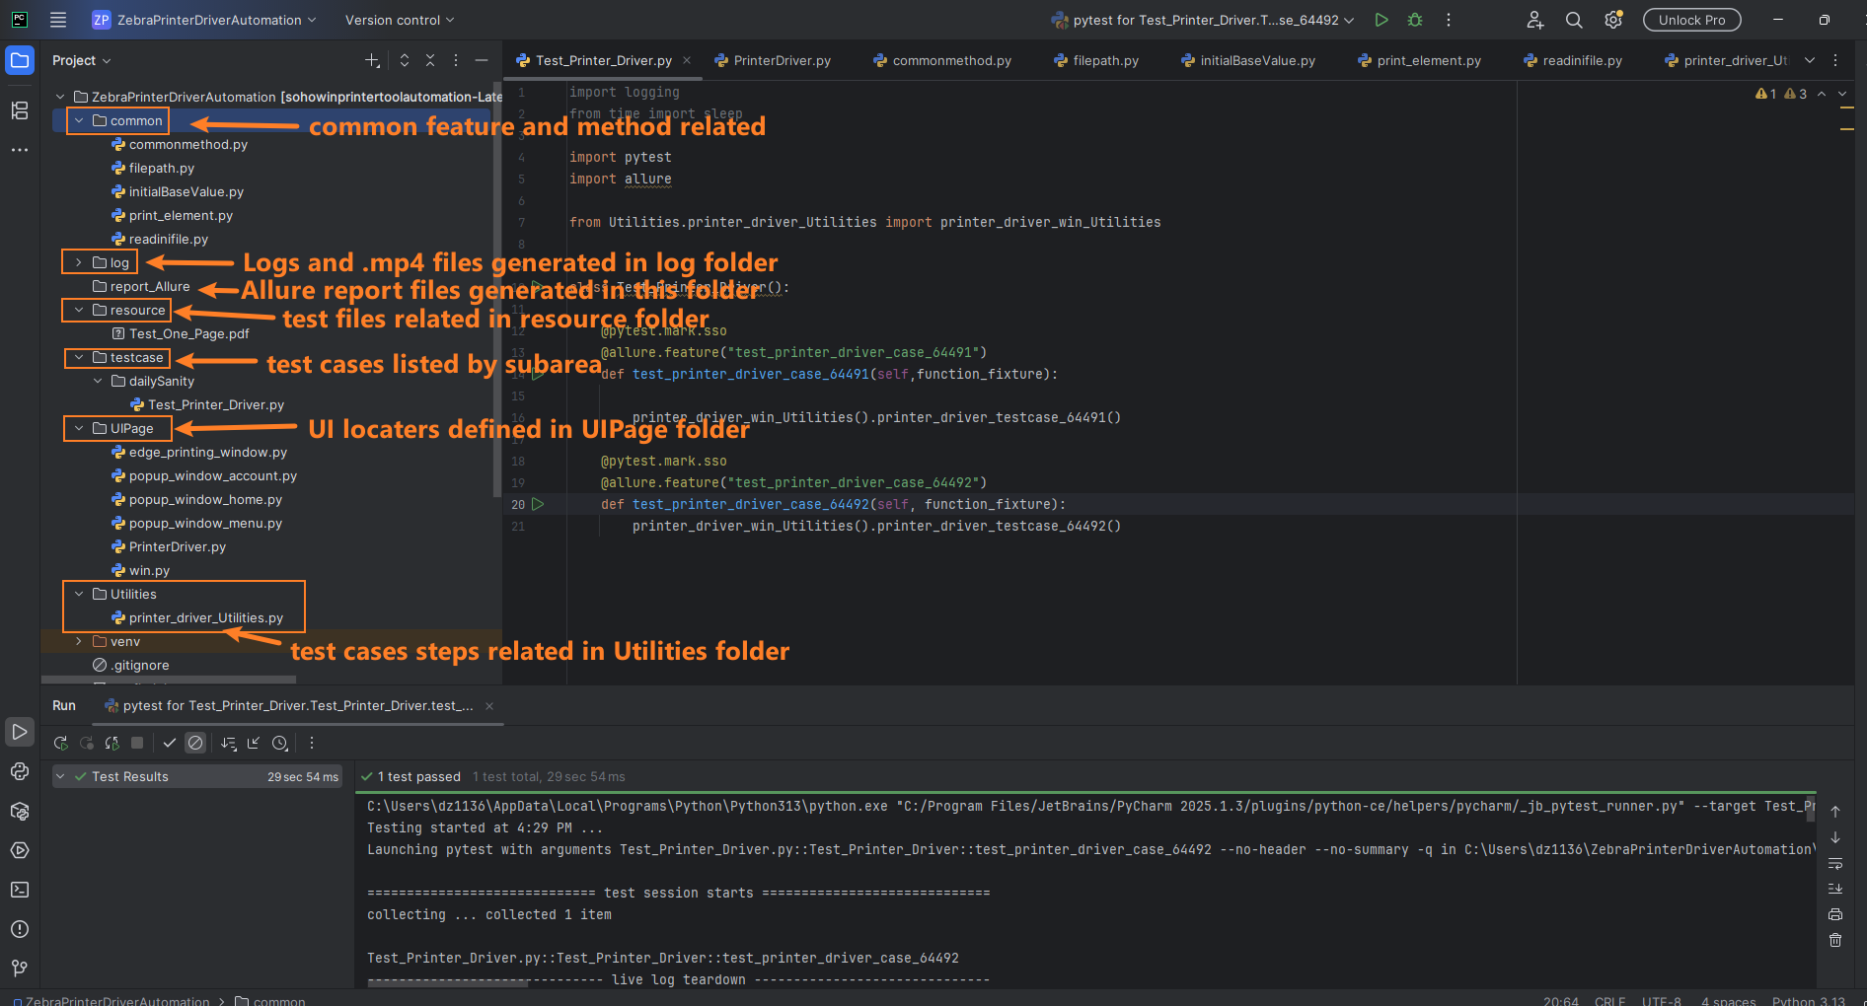

2.We will define the test cases for each subareas in testcase folder

3.In test cases we can design the test steps according to TDMS

4.For each elements we can define it in UIPage folder and call them

5.We can run the test in main method or try run the test case folder

6.We can check the video after running the test cases.

7.We can get the test report in **report_Allure** folder

